**CSR2-HUB database PRE-update manual (last update 13.08.2025)**

Please follow the instructions carefully to avoid mistakes and complete the database update as quickly as possible.For example, update 5.8.0 OTA2 will be shown, new cars: *- AstonMartin_DBR22_2023   
- Bugatti_W16MistralWRE_2024  
- DeTomaso_PanteraGT5S_1984  
- Mazda_RX7F2_1993  
- Porsche_911TurboFlachbauC_1987  
- Porsche_911STReward_2024  
- Porsche_911STRewardRecycled_2024*

+ Legends from 5.8.0 OTA3

1. ***Preparing and adding data from data/data space***
   1. ***Icons update***

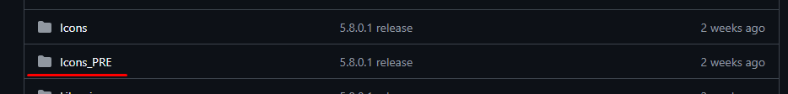

***To update icons, the hub has a special folder Icons_PRE. Please use only this folder for updating!***

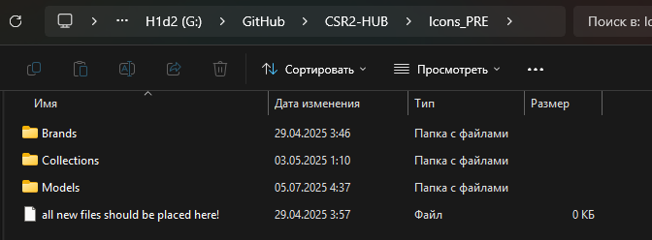

***Like the base folder, it has three additional folders:*** *- Brands: here are all car manufacturers, add a new manufacturer icon if a new one appears, or need update to new design  
- Collections: these are special icons that are used for collections and other things. It only updates when the hub app itself is updated, so skip this folder.  
- Models: here are icons of all cars. Update when new cars appear.*

In this case we have new cars and a new brand: DeTomaso + Mercedes update.

1. Open root/data/data/com.naturalmotion.customstreetracer2/files/NativeDownload/AssetBundles/ASTC
2. Search for _icon and sort by name:

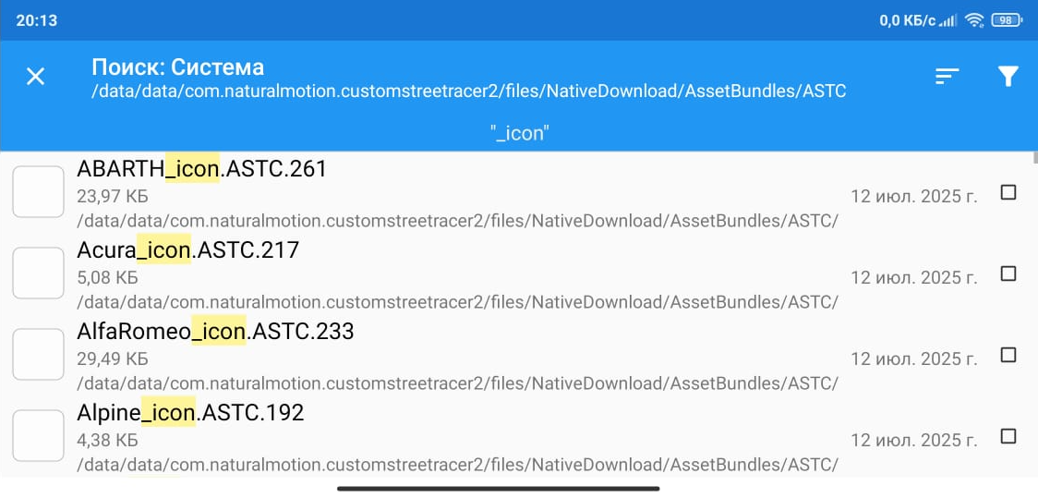

1. Find all the new cars you need, as well as the new manufacturer, copy them to a convenient location and then send them to your computer:

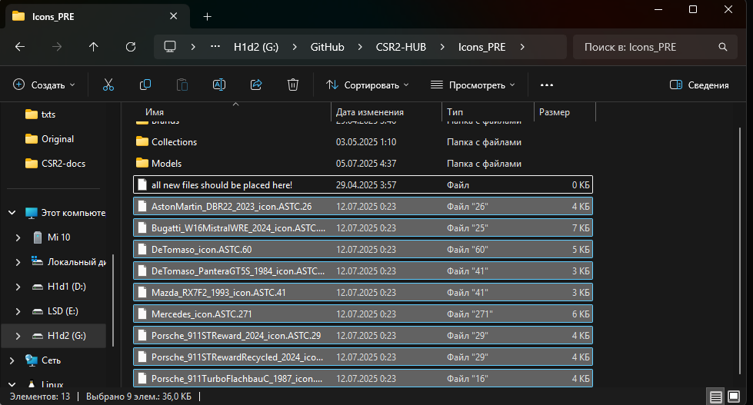

1. Open brand files in AssetStudio (AS) and filter by texture2d:

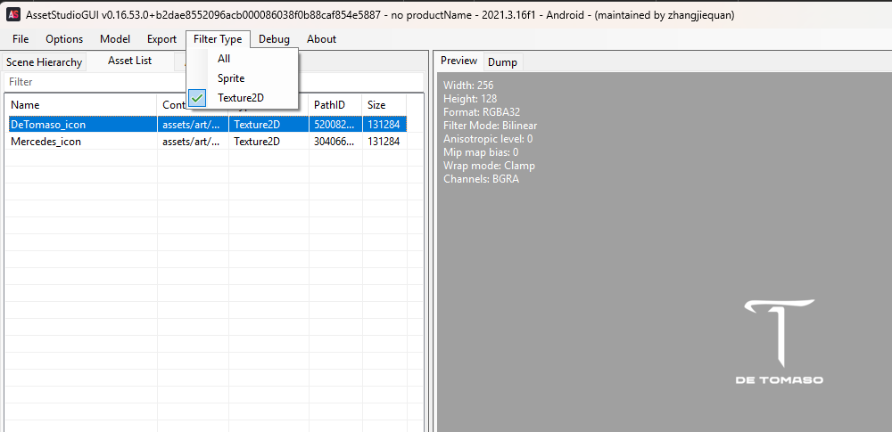

1. Export icons to Brands folder: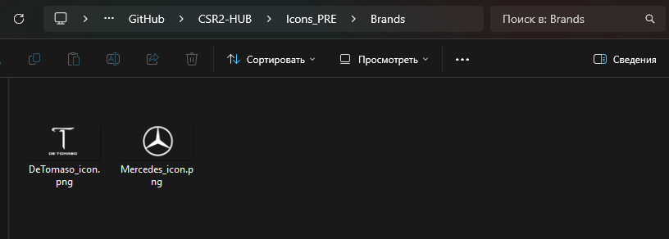
2. Open the remaining files in AS and filter by texture2d :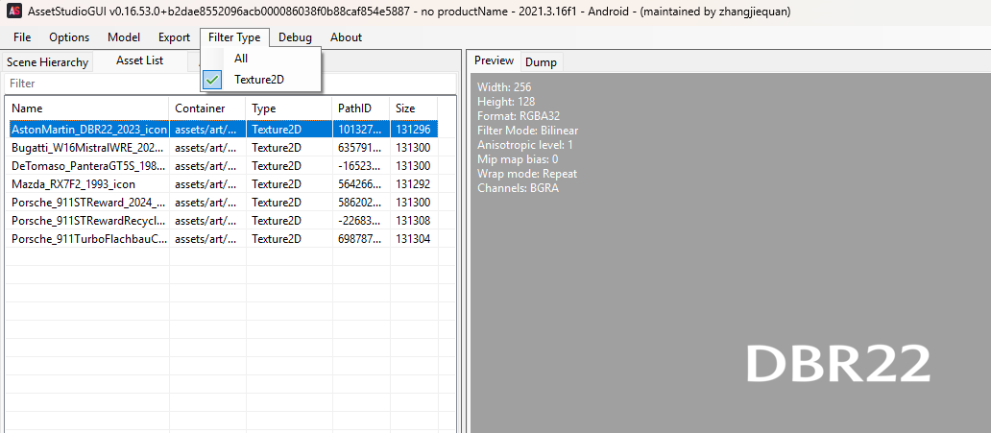
3. Export icons to Models folder :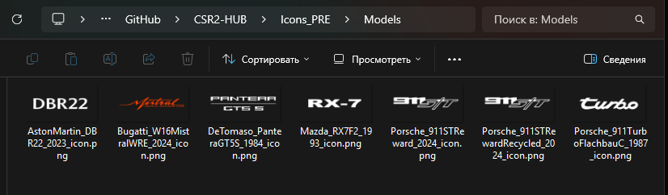
4. Delete ASTC files, they are no longer needed
   1. ***CarVisualData update***

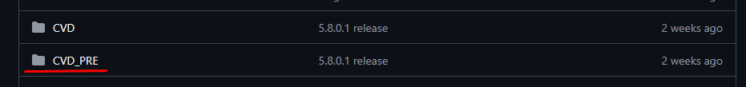

***To update CVDs, the hub has a special folder CVD_PRE. Please use only this folder for updating!***

Now we need to add CVD files for all new cars.

1. Open root/data/data/com.naturalmotion.customstreetracer2/files/NativeDownload/AssetBundles/ASTC
2. Search for _common.ASTC and sort by date :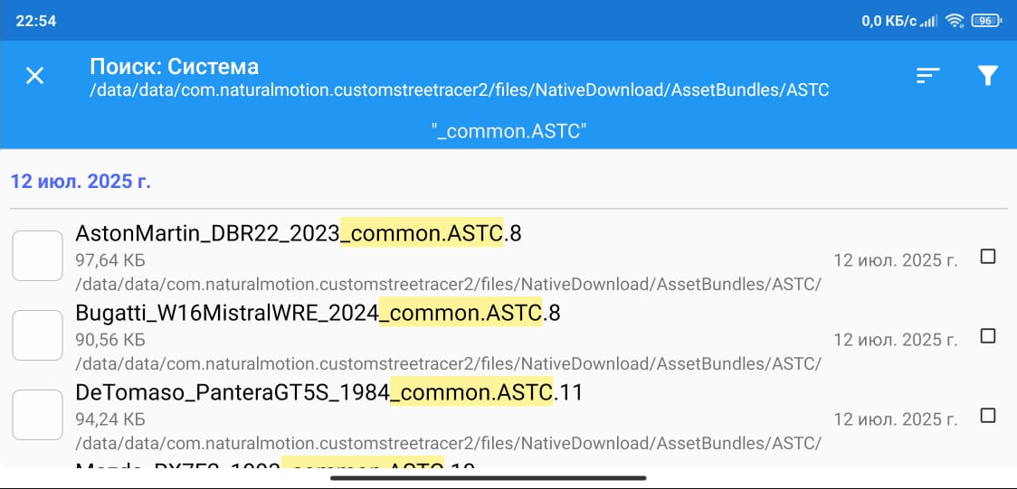
3. Find all the new cars you need and copy them to a convenient location and then send them to CVD_PRE folder :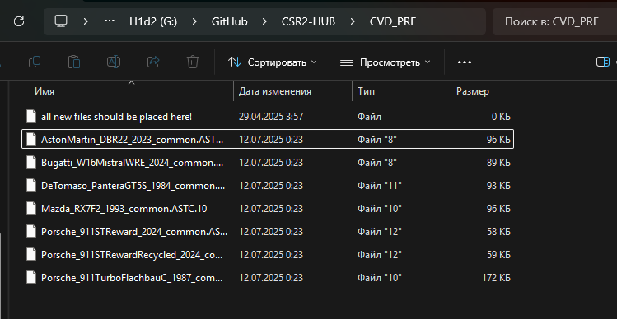
4. Rename the files so that there is only the name car-crdb :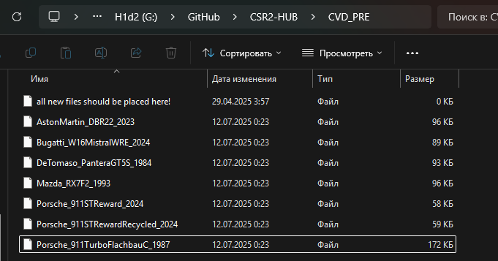
   1. ***CarConfigs update***



***To update CarConfigs, the hub has a special folder Libraries_PRE. Please use only this folder for updating!***

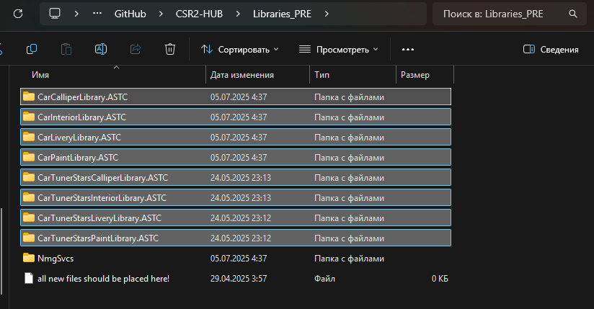

***Like the base folder, it has additional folders:*** *- Each has a file name that is needed for updating.*

Now we need to load new version files.

1. Open root/data/data/com.naturalmotion.customstreetracer2/files/NativeDownload/AssetBundles/ASTC
2. Search for Car and sort by date:

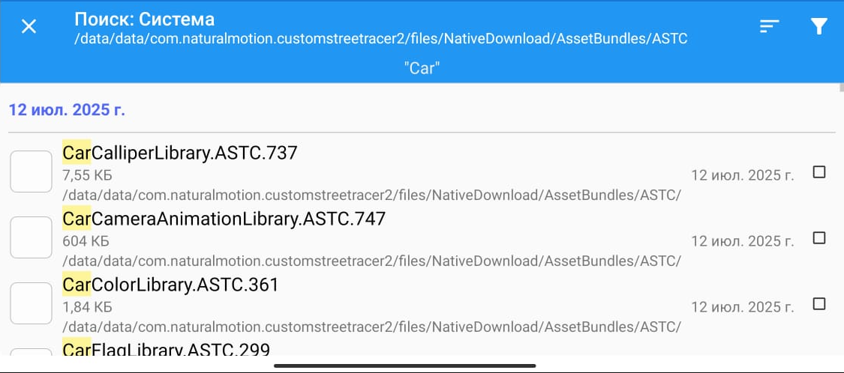

1. Find all the new files you need and copy them to a convenient location, then send them to each designated folder:

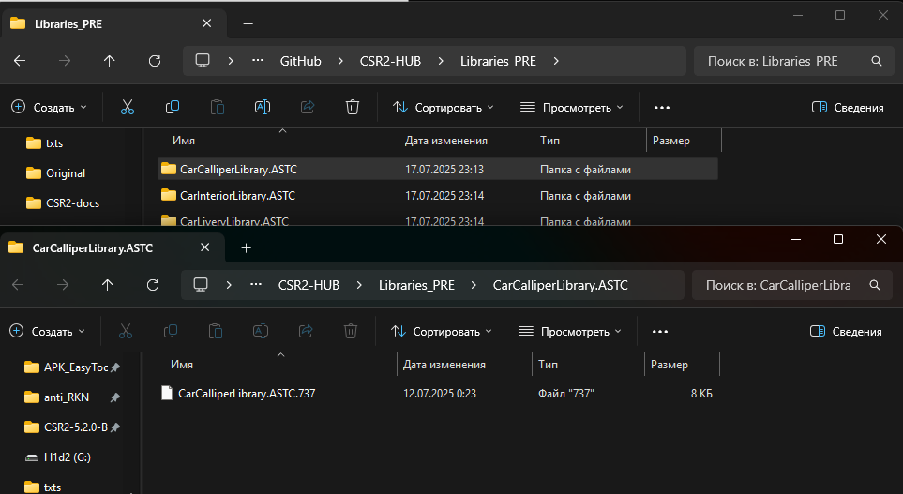

1. Rename each file to __data (!!! In name double underscore!!!)

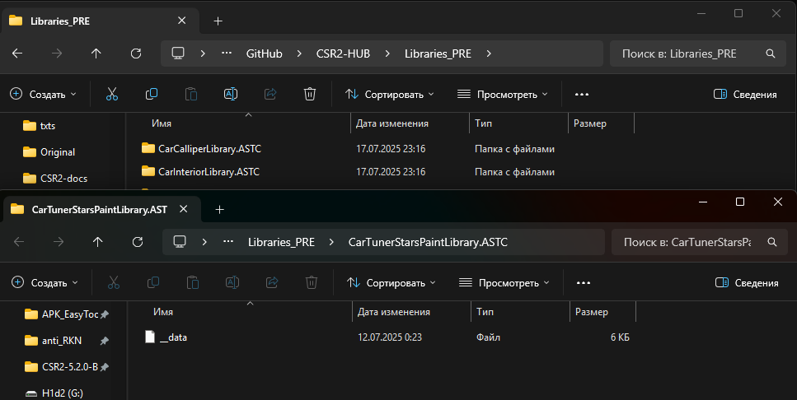

* 1. ***Localisation files update***



***To update localization files, the hub has a special folder Libraries_PRE. Please use only this folder for updating!***

Now we need to load new version files.

1. Open root/data/data/com.naturalmotion.customstreetracer2/files/NativeDownload/AssetBundles/ASTC
2. Search for Localisation_ and sort by date:

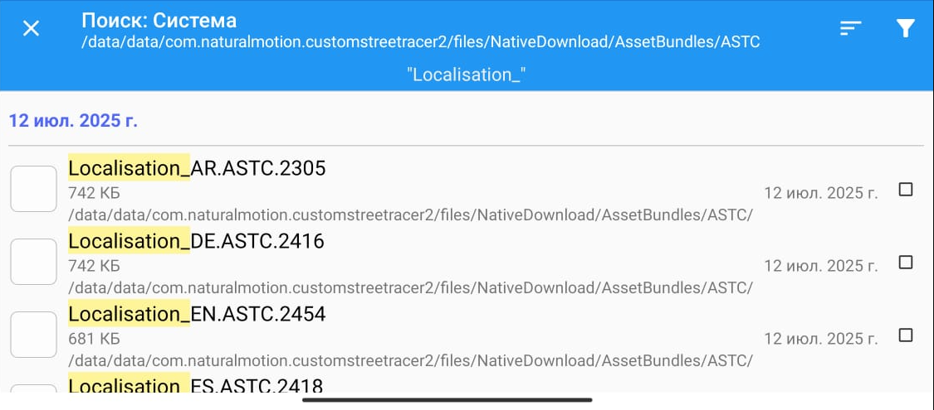

1. Find all the 12 localisations you need and copy them to a convenient location and then send them to Libraries_PRE folder:

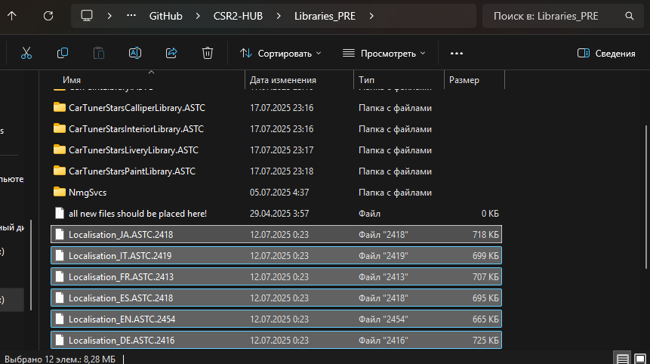

1. Rename the files by removing unnecessary numeric extensions:

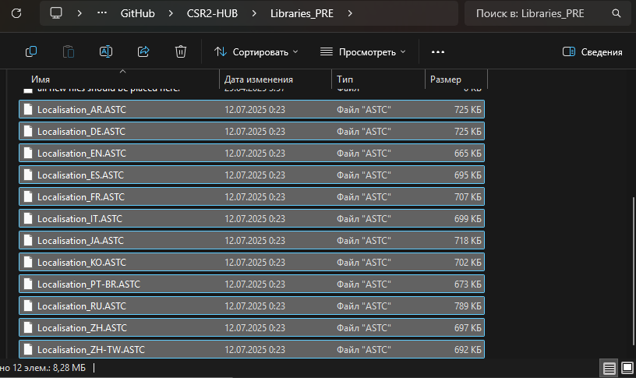

1. ***NmgSvcs files update***

In this step we will use the document files from the android/data folder of the game. So, make sure that it is up to date (has access to the crew view).

List of required configs:

- CarFusionProfileData

- CarMilestoneData

- CarPricingCompact

- CollectionCarsUnlock

- CollectionSlots

- NewCarsInThisAppVersionList

- OldCarsInThisAppVersionList

- ProfileBanners

- SeasonPassMilestoneRewards

- SeasonPassSchedule



***To update localization files, the hub has a special folder Libraries_PRE. Please use only this folder for updating!***

1. Open android/data/com.naturalmotion.customstreetracer2/files/Documents/NmgSvcsData/1/ConfigData
2. Copy all folder files to NmgSvcs folder:

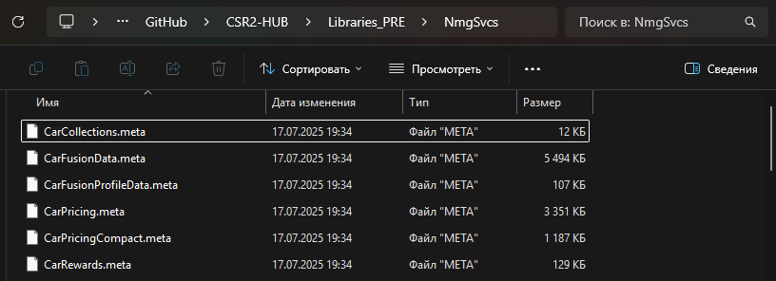

1. Find all necessary configs (except OldCarsInThisAppVersionList) and rename meta to json. Delete other files. *(Some files may be missing if they haven't been updated by the developers, so that's okay)*

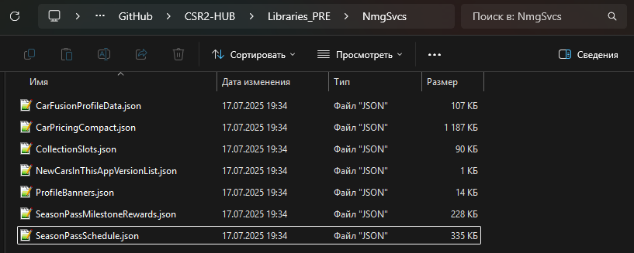

1. Make duplicate NewCarsInThisAppVersionList.json from Libraries/NmgSvcs and move file to Libraries_PRE/NmgSvcs -> Then rename this file to OldCarsInThisAppVersionList.json:

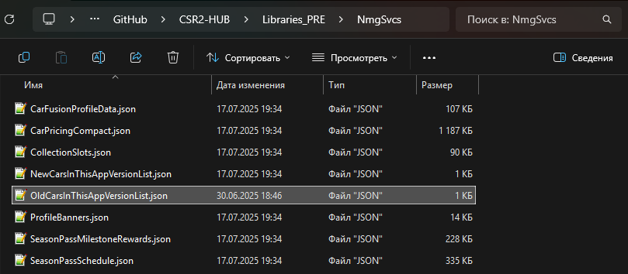

1. Open all json files (except CarsInThisAppVersionList) in Notepad++ and make JsonSort

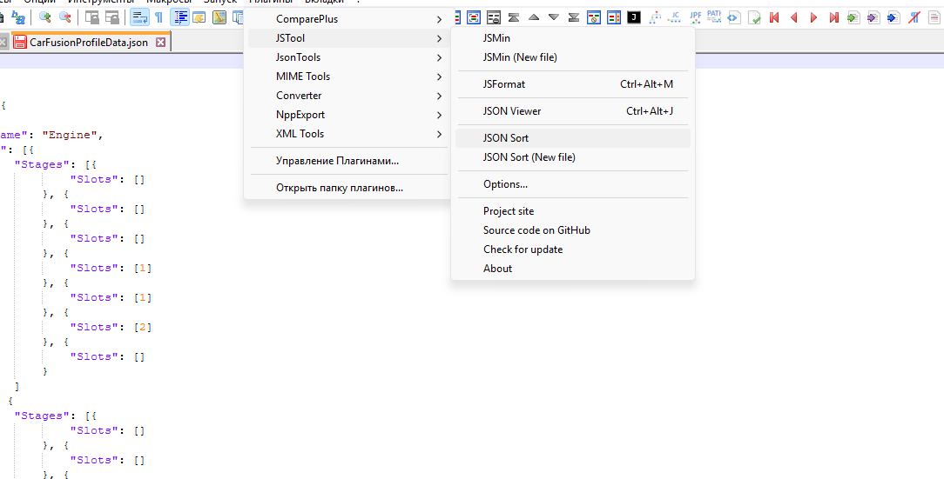

1. ***Processing purple cars***

In this and subsequent stages there will be work with NSB and cars. Now it is necessary to add purple/legend/TNR cars for get snapshots [512x]

1. Load account and get NSB
2. Add new cars (except gold) to inbox via picl. [gacha -1]

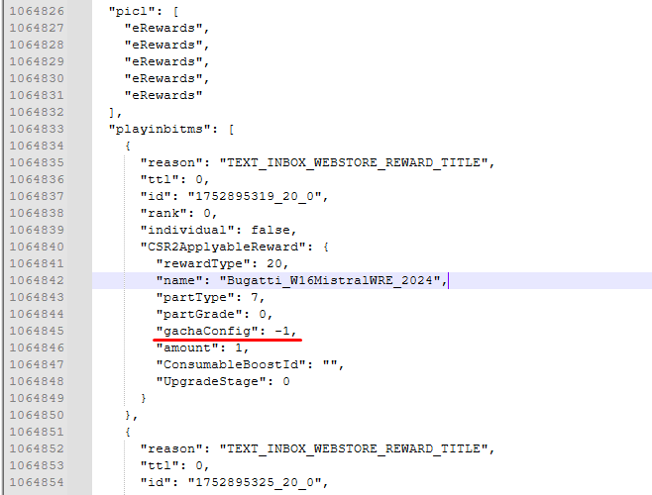

1. Launch the game, get new cars and close the game



***To update snapshots, the hub has a special folder Snapshots_PRE. Please use only this folder for updating!***

1. Go to android/data/com.naturalmotion.customtreetracer2/files/CarSnapshots/id/Default and copy snapshots new cars:

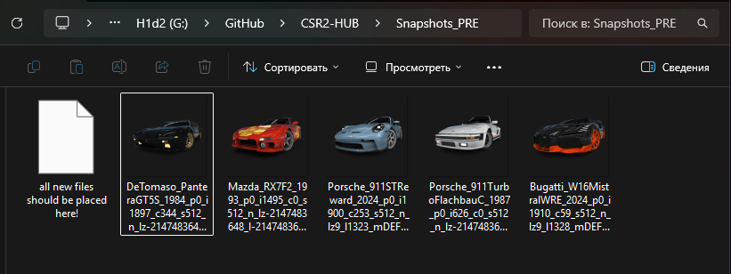

1. Next, you need to create folders according to the hierarchy principle: brand -> crdb; for each car:

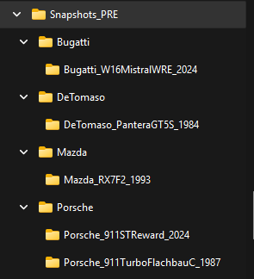

1. Move each snapshot in its corresponding folder and rename it to snap.png

(!!!For legends snap_uc.png!!!)

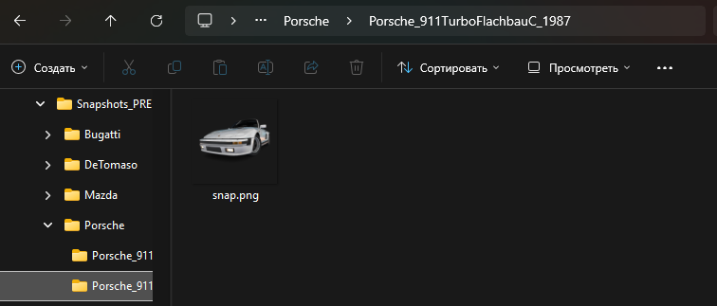

1. ***Processing gold cars***

Now it is necessary to add gold cars with all gacha options and get snapshots [512x]

Repeat the following steps for each car separately:

1. Go to CVD_PRE and open CarVisualData target car in AS

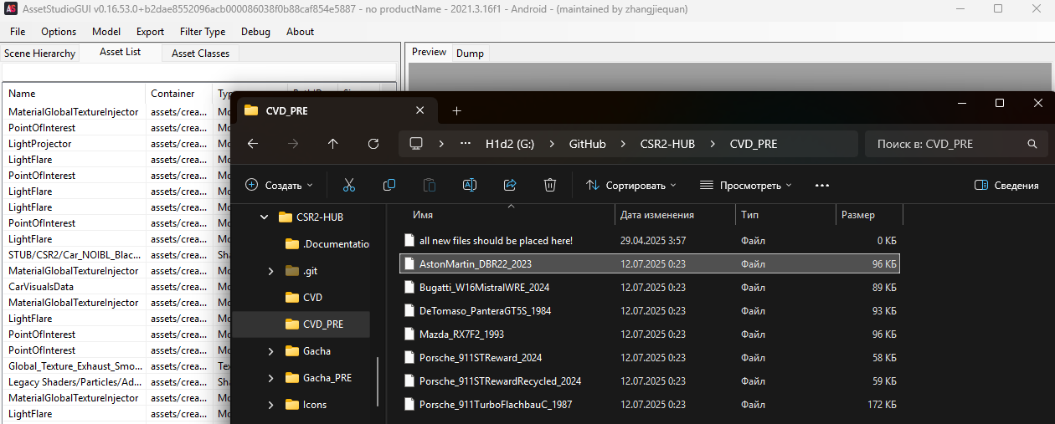

1. Open CarVisualData file and count the number of elements in GachaConfigs

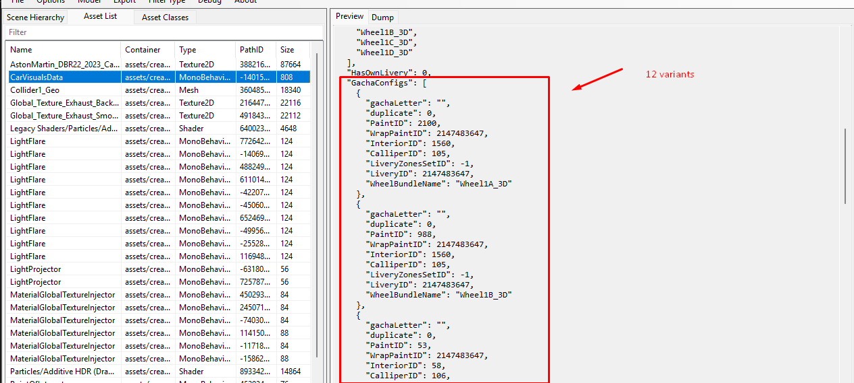

* If the elements do not contain duplicates (“duplicate” always 0): add all cars from 0 to the last element. Example: Aston has 12 variants, so we will add cars with index from 0 to 11
* If elements contain duplicates: skip all cars with duplicate value -1, but continue counting. Example: Aston has 4 variants, but we see that the second variant has 1 duplicate, therefore: we will use only indexes 0, 1, 3 *(2 is skipped because it is a duplicate)*

1. Add new cars to inbox via picl according to indexes:

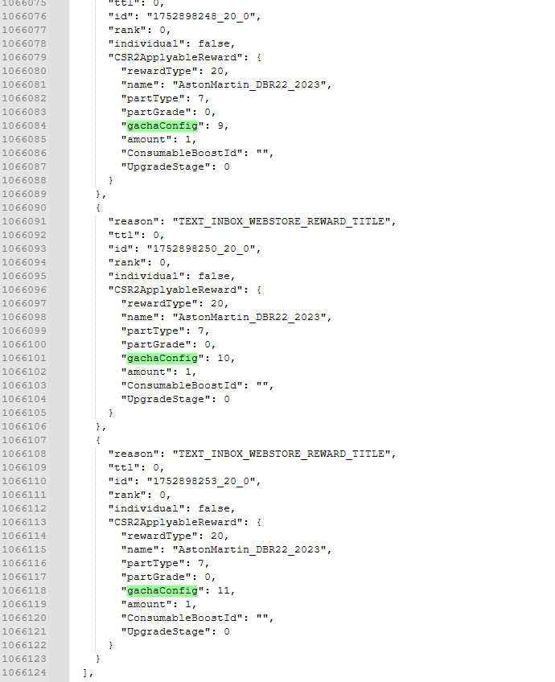

1. Launch the game, get cars and close the game
2. Create folder for car also according to the hierarchy principle:

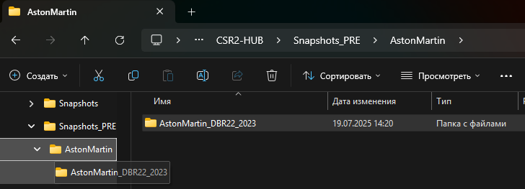

1. Go to android/data/com.naturalmotion.customtreetracer2/files/CarSnapshots/id/Default and copy all snapshots new car to folder:

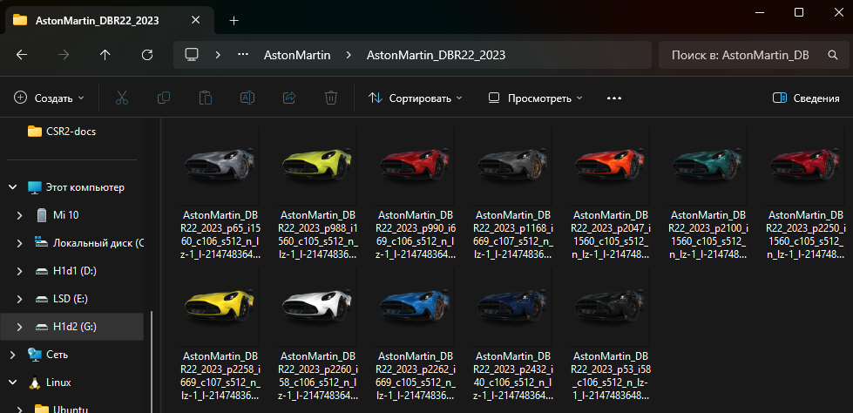

1. Rename each snapshot according to fgc: for example, if fgc4 - 4.png

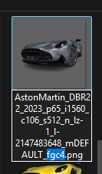 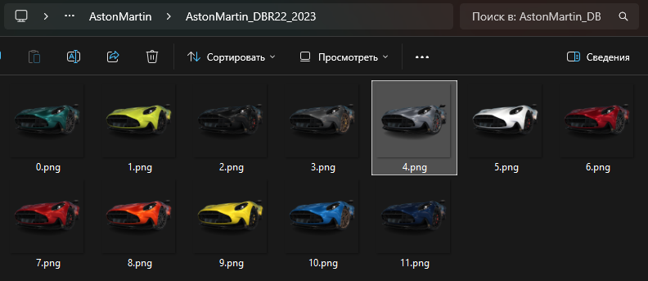

1. ***Processing full snapshots***

Now it is necessary to get full cars snapshots [1024x]



***To update snapshots, the hub has a special folder Snapshots_PRE. Please use only this folder for updating!***

1. Enable 1024x function in Fusion:

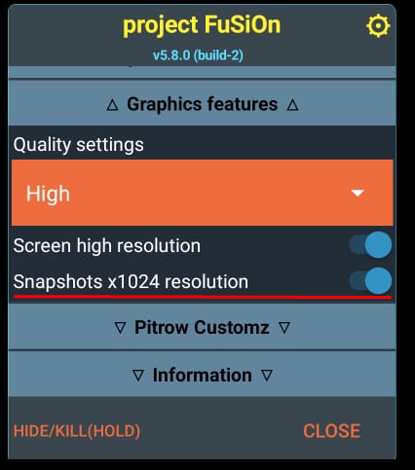

1. Add all new cars to inbox via picl. [gacha 0]

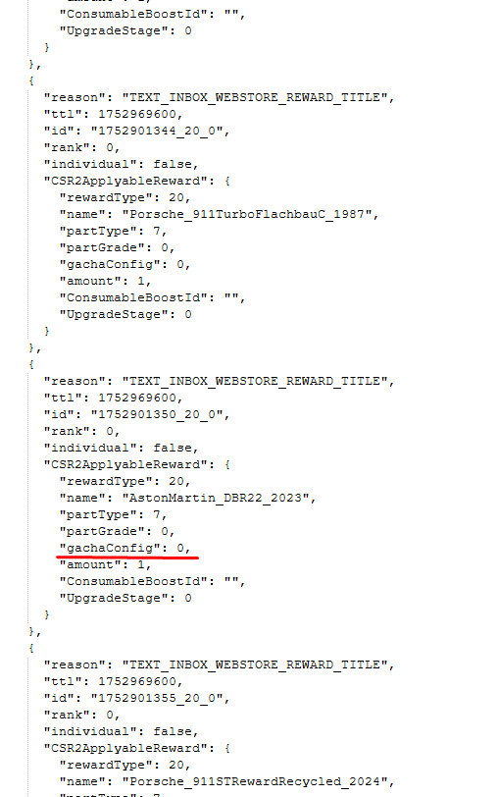

1. Launch the game, open the box and wait until all the snapshots are ready. (no need to pick up the cars)

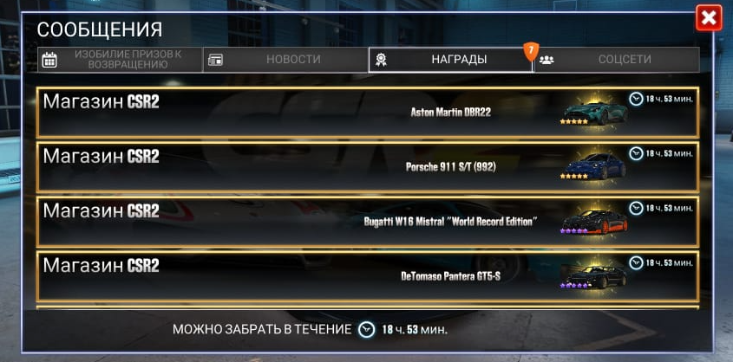

1. Go to android/data/com.naturalmotion.customtreetracer2/files/CarSnapshots/id and copy snapshots new cars to folder:

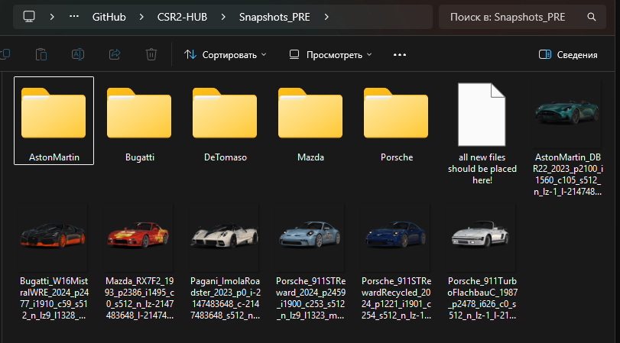

1. Move each snapshot in its corresponding folder and rename it to snap_full.png:  
   (!!!For legends snap_full_uc.png!!!)

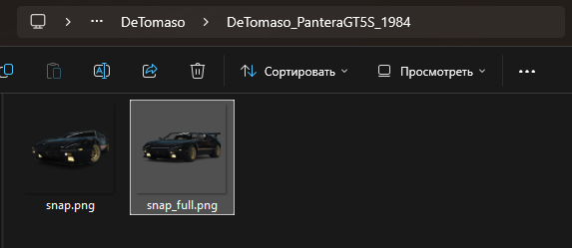

1. ***Processing legends cars***

We have already added a LEGEND car before, but it was an unrestored state. Now we need to prepare data for the restored and elite states.

1. Disable 1024x function in Fusion
2. Restore cars twice: then leave one untouched, the second elite max

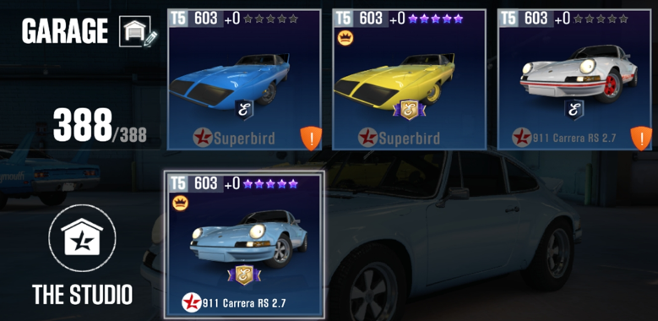

1. Save snapshots for each car to Snapshots_PRE (snap.png + snap_ec.png)

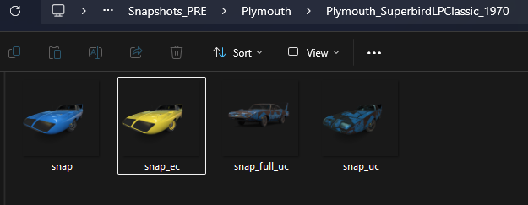

1. Enable 1024x function in Fusion
2. For each car: entry car unid to CollectionUID

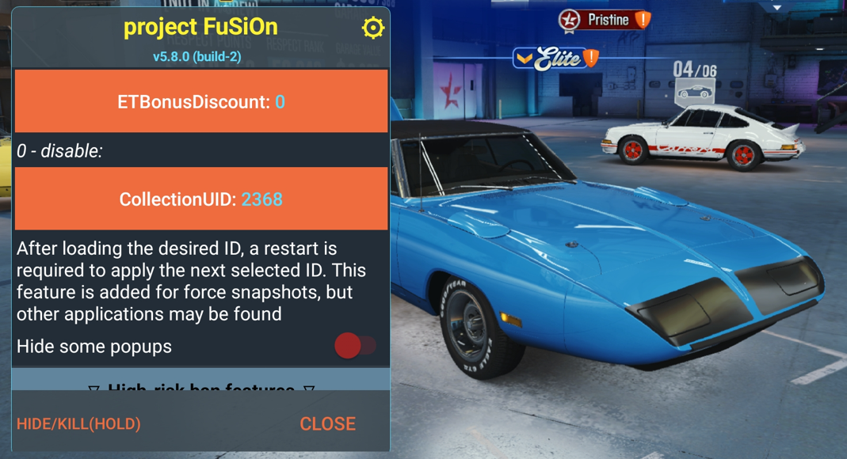

1. For each car: open any collection with your locked car

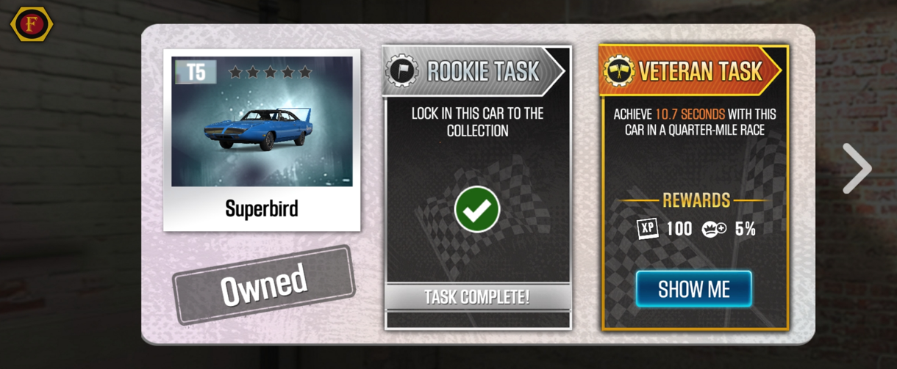

1. Save snapshots for each car to Snapshots_PRE (snap_full.png + snap_full_ec.png)

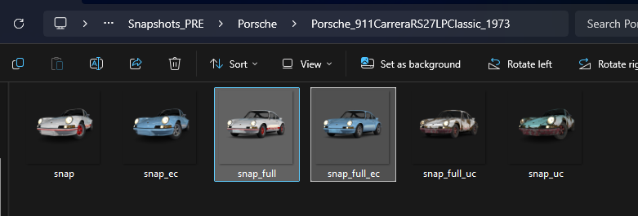

1. ***GitHub upload***
2. Open GitHub desktop and click fetch origin or/and pull origin:

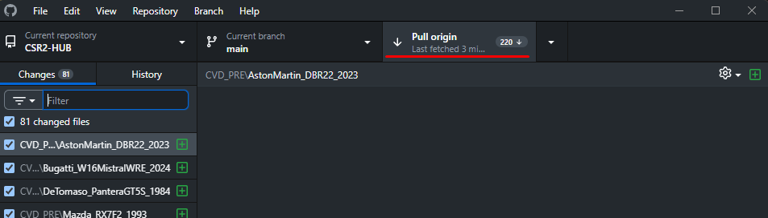

1. Write summary and click commit:

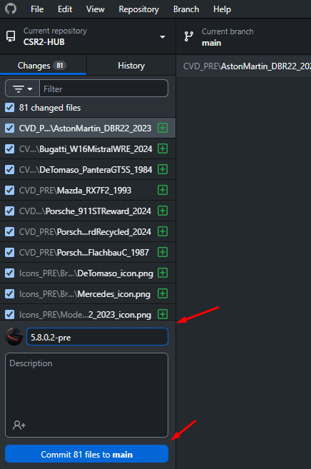

1. The final step is to press push origin:

